MVC PATTERN
MVC Pattern
The ShopEZ backend application follows the Model-View-Controller (MVC) architectural pattern.
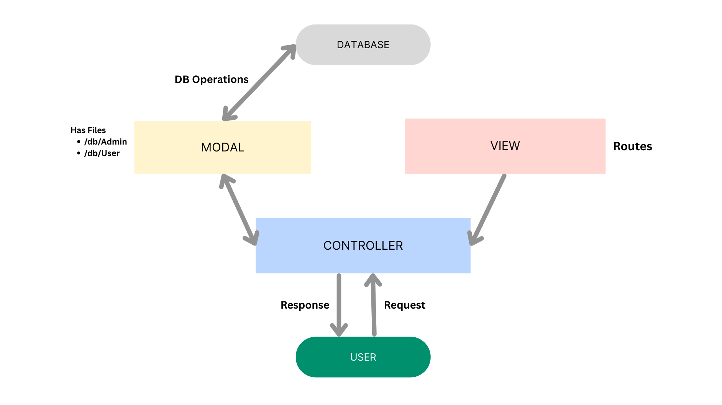
Model Layer
The Model layer handles all database-related operations. It defines schemas and models using Mongoose and interacts with MongoDB.
Controller Layer
The Controller layer processes incoming requests, performs business logic, interacts with models, and returns appropriate responses.
View Layer (Routes)
The View layer is implemented through API routes. It defines endpoints and connects client requests with controller functions.
Advantages of MVC
- Separation of Concerns
- Better Code Organization
- Easier Maintenance
- Improved Scalability
- Reusability of Components
- Simplified Testing
- Better Team Collaboration

